INTERNET, MAILING, MANAGEMENT OF WEBSITES

Training materials | Version 2  5 2019

Table of Contents
Introduction 3
A. Basic information 4
1. Creating a website 4
2. How to send e-mail marketing correctly 8
3. Newsletter – what is it? 13
4. Tips for creating content on the Internet 17
4.1. The inverted pyramid principle in the creation of texts ………………………………………17
4.2. Formatting text in articles posted on a website 18
4.3. Rules for creating information titles 19
4.4. Rules for the construction of a correct leader 20
4.5. How to create subheadings in information 21
4.6. Placing links in text 22
4.7. Negative comments on the Internet 23
4.8. The most important issues regarding copyright 24
5. Tips for increasing the number of visits to the website 27
B. Further information 31
6. What is CMS and do I need it? 31
7. Website positioning - what is it and what does it depend on? 35
8. Tips for creating content on the Internet 39
8.1. Creating press releases 39
8.2. Reporting from events 40
8.3. Rules for the publication of photos from online databases 41
8.4. Creating photoreports 42
8.5. Creating infographics for publication on a portal 42
9. Bibliography 44

Introduction
In today's world it is becoming increasingly difficult to conduct any activity while remaining closed to the possibilities offered by Internet resources. In connection with the above, it is important to learn the basic knowledge through which it is possible to actively participate in the "virtual world". These materials are designed to provide the most important information that will answer the following questions:
- How to set up a website.
- What a domain, server and hosting are.
- What the CMS (Content Management System) is.
- How to correctly send e-mails and what rules to follow.
- Why a newsletter is an interesting tool for contacting a client.
- Why positioning plays such an important role and how it affects the success of a specific website.

- Basic information
- Creating a website
In order to set up your own website, you need two essential things, namely a server (hosting) and a domain. A server (hosting) is the place where the site and all its resources will be located (this can be compared to the disk found in every computer). We must here separate the server from the virtual server, called the hosting. The hosting is a place separated for users located on the server. More information on the differences between the hosting and the server will be presented later in the materials.

In turn, the domain is nothing else than the name of the site, e.g. yoursite.pl. When buying a domain, there are many possibilities, because it can be with the ending ".com", ".com.pl", ".info", ".net", ".eu", ".biz", etc. The domain ".pl" is a national domain and, for example, ".com" or ".net" are global domains. It is worth adding that a ".pl" domain is usually the most expensive. Global domains are cheaper by even half, and the cheapest are regional, e.g. ".waw.pl". There are also regional commercial domains, such as ".com.pl". The first registration of a domain usually takes place on promotional terms and costs little or nothing, but every year it needs to be renewed, which costs (depending on the domain and the service provider) from 40 to 120 PLN. The vast majority of hosting companies offer sales of both hosting and domains. Thus, the domain will be registered where the server is bought, although it can be done where it is cheaper and be connected to your server.

Figure 1. What is a domain?
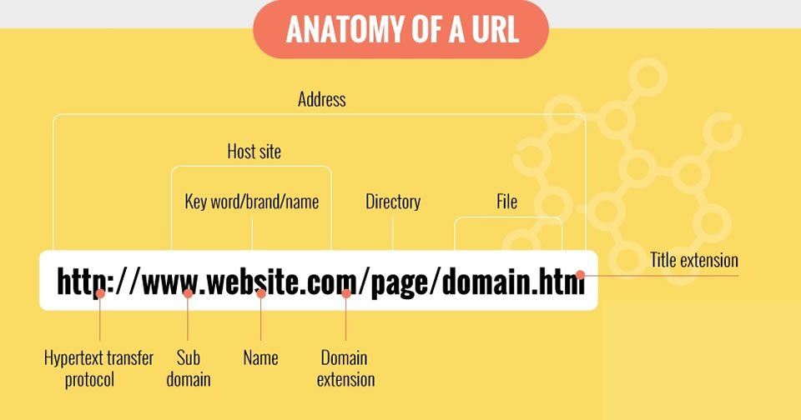
Source: https://www.websitespot.com/blog/what-is-domain-name-infographic/

Which server to choose and what to look for.
In response to the above issue, there are plenty of hosting companies on the market. The best known in Poland are "home.pl" and "nazwa.pl", but it is necessary to pay a lot more for their services than in the case of less well-known companies. It should also be remembered that not all service providers offer with a hosting account such solutions as a page creator or an installer of popular scripts, thanks to which even an inexperienced person will create his website easily.
When choosing a hosting site, some important points have to be followed. The first one is what website you want to set up and what purpose it will serve. For example, there is no need to buy a more expensive service with all possible options and unlimited parameters if the site is to be just a company’s offer or business card. However, if business activities are to be carried out via a website, for example in the form of a store or service, it is worthwhile trying an extended package. If we want to run a store, we will probably need databases, FTP accounts, the ability to add subdomains and create email aliases (several email addresses on one domain). It is also good if the data transfer limit is at least 20 GB, all depending on the size of the page and the number of photo or video files, which generate a large transfer, and of course on the number of visitors. However, there is no need to worry, if you have chosen a poor hosting plan, you can easily change it to a "stronger" one.
Individuals who plan to put several pages on the server, must pay attention to the databases that are needed for most applications, scripts and each page, based, for example, on Joomla! or Wordpress. In this case, it is also necessary to be able to connect several domains.
The key point when choosing a domain is also their prices, because for a few sites it is the renewal of each domain that will be the largest expense. One way to solve this problem could be buying domains where they are cheaper and connecting them to your account.
The key parameter for sites offering exchange and downloading of files, having a large number of photos or their own video materials, which occupy many gigabytes, is account capacity and data transfer. This is especially important when setting up a website or a web store.
If the priority is to create a professional website with a large number of visitors, then you should look for the most professional company. In addition, before buying it is a good idea to test your hosting and see if everything works as it should. It is also worth paying attention to whether the company has regular backups as part of its service (preferably every day), which will restore the site in the event of a failure.
Interestingly, is not necessary to have hosting. Many companies offer the creation of a website, without purchasing and administering their own hosting account. Usually, such a service is a more or less advanced website builder. It is then possible to access your website only through the website creator, without having to worry about hosting. These types of applications work best if you need a company website with your company's offer, a business card page, an advertising page, etc.
Figure 2. How does web hosting work?
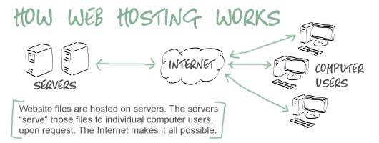
Source: https://websitesetup.org/what-is-web-hosting/

Figure 3. Types of web hosts and servers

Source: https://jakzalozycstrone.info/8-artykuly/21-serwer-i-hosting.html

In summary, there are many ways to place your files, pages, applications or mail on the internet. Companies operating in the hosting industry try to reach every kind of customer. Most of these companies have a very similar offer, but often with different technical and price conditions. So before buying a hosting account or server, it is a good idea to think about what you will need. If the service provider provides for a test period of a few days, it is also worth taking advantage of such an offer.

Exercise
- Check whether the domain you would like to set up is available. remote
- Try to set up your own internet domain. remote

- How to send e-mail marketing correctly
E-mail marketing is a great tool for building relationships and promoting sales. A well-prepared sales campaign, supported by a newsletter, can bring surprising results. Before you start producing creative work and sending mailings, you should know how to do it in accordance with the law.
Figure 4. Laws governing e-mail marketing

Source: https://marketingibiznes.pl/e-mail-marketing/abc-e-mail-marketingu-czyli-wysylac-mailingi-glowa/

The aforementioned acts are a pillar intended to ensure that advertising and promotional content sent to customers is provided in accordance with the law. Very often, other provisions apply, including an Act on Competition and Consumer Protection, an Act on Combating Unfair Competition and the Civil Code, in accordance with the legislation of a given country.

Figure 5. The benefits of e-mail marketing
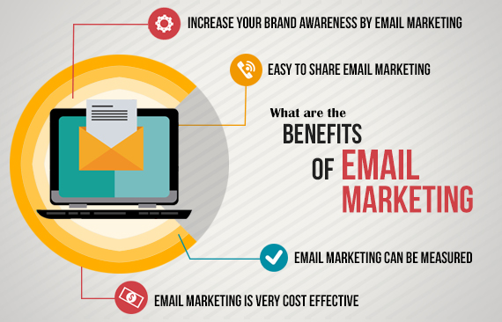
Source: https://www.iqinfotech.co.in/blog/benefits-of-email-marketing/
Once you have read the legal requirements for sending e-mail content and all of their conditions are have been met, you can start creating your own database.
The best and most valuable databases are "created by themselves". If a new recipient subscribes to the newsletter that you run, it means that he sees some goal in it, something that will bring him benefit or value.
Addresses can be collected in any way using different communication channels, not only online, but the most common are forms that are posted on websites, e-stores, blogs, as well as company profiles, for example on Facebook. Of course, filling out the form is voluntary, and the person who will do it must have the opportunity to express all the necessary consents, withdraw from subscription at any time and change their data (in accordance with applicable legal regulations regarding the protection of personal data).
Figure 6. Additional campaigns that allow you to obtain new, valuable records

Source: https://marketingibiznes.pl/e-mail-marketing/abc-e-mail-marketingu-czyli-wysylac-mailingi-glowa/
The purchase of a database of e-mail addresses seems to be a good solution for many businesses, mainly because in a relatively cheap and very easy way you can increase the volume of your recipients. If you have decided on this step, it is worth getting information about it first, because they are not always high-quality records. It should also be remembered that after the purchase of this type of information, we still have a statutory duty related to the processing of personal data.
If you decide to rent an e-mail base, you have to accept the fact that the addresses will not become your property, because you rent them for one or several shipments. In addition, a company whose records are used can itself prepare mailing based on reported guidelines, but this is usually for additional payment.
The figure below presents the methods of payment for renting a database. However, to sum up this topic, keeping in mind the legal restrictions related to the protection of personal data, the best solution for creating a database of customers who are interested in a specific product and service related to intangible cultural heritage is the gradual creation of your own mailing database.
Figure 7. The methods of payment for rental of a database

Source: https://marketingibiznes.pl/e-mail-marketing/abc-e-mail-marketingu-czyli-wysylac-mailingi-glowa/
Before the construction of the creation (the message that will be sent to recipients) is discussed, it is worth mentioning the types of messages that exist in the world of e-mail marketing.
Figure 8. Types of messages in the world of email marketing

Source: https://marketingibiznes.pl/e-mail-marketing/abc-e-mail-marketingu-czyli-wysylac-mailingi-glowa/
Each of these types of messages looks a little different, but it is worth remembering that all have a common identification (the look of the message, logo/name of the institution, the colours used), thanks to which the subscriber will know from whom he received the mail.

Figure 9. Features of a well-prepared email marketing creation

Source: https://marketingibiznes.pl/e-mail-marketing/abc-e-mail-marketingu-czyli-wysylac-mailingi-glowa/

Figure 10. Tips for effective e-mail marketing
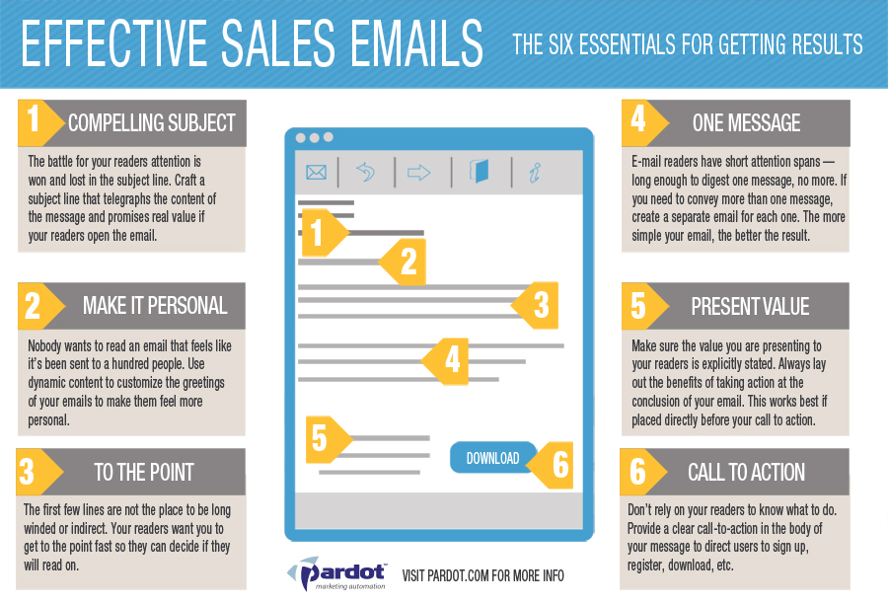
Source: http://emarketingblog.nl/2014/11/best-tips-for-email-marketing/
Exercise
- Check your e-mail address. How many e-mail marketing messages have you received in the last week/month? remote
- Which of them do you find interesting, and which do you not? oral
- What could be improved in e-mail creations that you have recently received? oral

- Newsletter – what is it?
Recently, the newsletter, i.e. a type of online newsletter sent cyclically to interested subscribers (people who signed up to receive such information) has become an increasingly popular form of communication with the client. It is selected by small and medium-sized companies as well as the largest corporations and concerns. What exactly is this form of marketing, why is it worth choosing your own newsletter and how should we choose the perfect system for sending newsletters?
According to the simplest definition, a newsletter is a type of bulletin (usually delivered in the form of an e-mail message) to which customers subscribe voluntarily by providing their data. Most often they contain information about new products introduced to the company's range, special promotions or sales, planned events or the events of other types of changes in the products and services offered.
The newsletter is one of the most effective ways to build a relationship between the brand/company/institution and the client, primarily because to receive it, you must voluntarily subscribe to it. Therefore, these messages are not just annoying advertisements for services that we are absolutely uninterested in, but rather information material allowing the customer to stay in constant contact with a company/institution that he is interested in, the development of its offer and changes in the services it proposes.
Figure 11. Why is it worth having a newsletter?

Source: http://www.echopr.pl/blog.php?id=26
Figure 12. Good practices in the creation of a newsletter
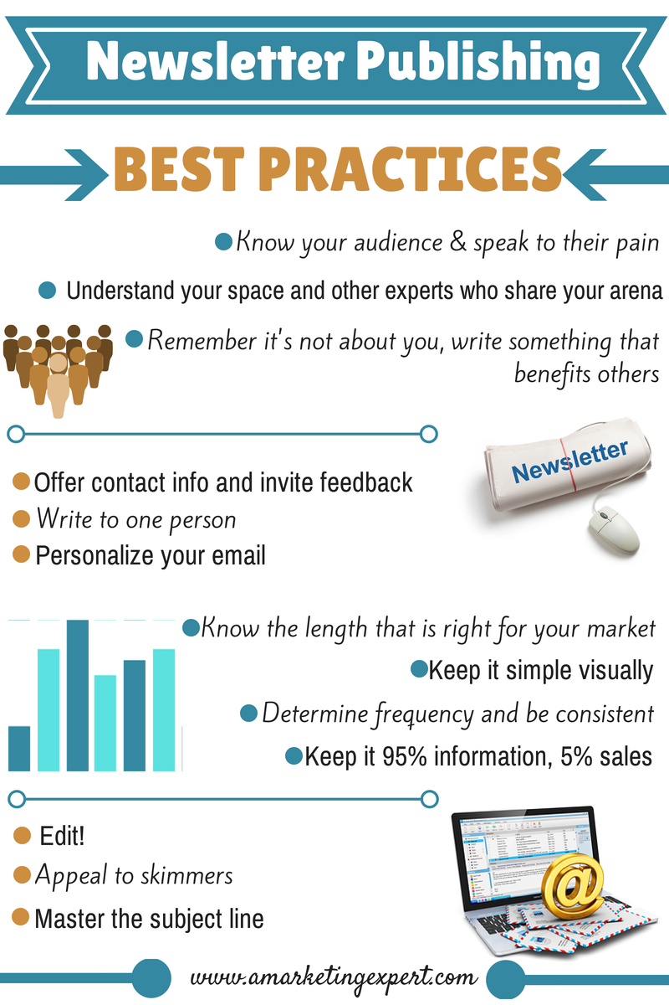
Source: http://www.amarketingexpert.com/wp-content/uploads/2014/09/Newsletter-Publishing-Best-Practices.png
In order to create a good newsletter, it is necessary first of all to determine what information we want to convey to the client in it, with what frequency and what group of recipients we consider the target.
It is also important to determine one unchanging appearance of the newsletter template. It should be clear, contain the most important information and links redirecting to pages where we can find more details about news, events and promotions, and should not be changed every few weeks or months. Customers get used to the specific look of a newsletter and often very quickly start to connect this look with the offer of the company/institution.
It is also important to determine the frequency of sending the newsletter and the day when it will be sent, because customers get used to the fact that messages from companies that they are interested in come on a specific day of the week or month, and a disturbance of this cyclicality may create an impression of chaos and poor management of the newsletter.
Each newsletter should also contain something inaccessible to people who do not subscribe to this type of marketing information of a given company. Most often these are discount codes, special promotions for newsletter subscribers, information about the start of sales of a specific type of goods, guides related to the products or services offered by the company, or faster access to information that will later appear on the website.
Newsletters are often referred to as mailings due to the form in which they are delivered to the customer, i.e. e-mail. However, this is not completely correct. Mailing, according to the traditional definition, differs significantly from the newsletter.

Figure 13. Differences between newsletter and mailing

Source: http://www.echopr.pl/blog.php?id=26

The decision about choosing an appropriate mailing system through which we will send a newsletter is very important. There are many of them on the market, so every company/institution that starts running a newsletter should know what to look for when choosing a system. Below there is a list of the most popular systems for sending newsletters.
Figure 14. The most popular systems for sending newsletters

Source: http://www.echopr.pl/blog.php?id=26
The most useful functions of mailing platforms for sending newsletters - what to look for.
In addition to the price, an important point when choosing a mailing platform for sending a newsletter is to consider the additional features offered by different providers. Almost all systems now offer intuitive creation of newsletter templates. Also, almost every supplier offers the possibility of performing an A/B test for sending a newsletter, which consists in dividing the mailing list into three groups - two smaller ones and one larger one. The system sends the newsletter in different versions to the two smaller groups, usually differing by e-mail title or sender's name. By analysing the openings of e-mails and clicks on links contained in them, the system determines whether version A or version B of a given newsletter is more effective and this version is sent to the largest third group of recipients in order to get the best results in reaching potential customers.
Most newsletter delivery systems also offer basic segmentation of subscribers, consisting in dividing the mailing list into smaller subgroups, to which will be sent specific newsletters with offers tailored to their needs. The basic segmentation of subscribers can include, among others, division by sex, age, location, defined by the client himself, or selected by way of research into the subscriber’s behaviour on our site.

Exercise
- Check your e-mail address. How many newsletters have you received in the last week/month? remote
- Which of them do you find interesting, and which do you not? oral
- What could be improved in the newsletters that you have recently received? oral

- Tips for creating content on the Internet
This chapter contains advice on how to properly create materials for publication on the Internet.
  - The inverted pyramid principle in the creation of texts
Both press and internet texts should be prepared in accordance with the principle of the inverted pyramid. This principle consists in the fact that the most important information that is contained in a given article should be at its beginning. This design is intended to allow the reader to find out what the material is about, thanks to which you can hold his attention and encourage him to read the whole text. Each subsequent paragraph should contain less relevant, more detailed information, as well as side issues.
The appropriacy of applying the inverted pyramid principle has been proved in eye tracking studies (following the line of sight). Internauts usually read quickly and carelessly, directing their eyes to the first passages of texts. According to research, the key area of ​​articles published on the Internet is the top left corner. That is why the most important information should be placed there - the higher and closer to the left it is, the greater the chance that readers will get to know it.
The principle of the inverted pyramid is also relevant to the characteristics of creating and publishing content on the Internet. The materials placed on the net are often modified and written in an open manner, and thanks to the above principle, it is easy to change them and find the necessary details.
Figure 15. The construction of a text in accordance with the principle of the inverted pyramid

Source: own elaboration based on materials from Exacto Sp. z o.o.

  - Formatting text in articles posted on a website
Using unified text formatting rules significantly increases its aesthetics and transparency. Systematic rules applied when writing an article allow the reader to pay attention to the most important information contained in the text.
Correct formatting is especially useful in texts that contain a large amount of detailed information. This allows the highlighting of key issues and significantly shortens the search time for specific information.
The basic principle of formatting is to take care of it after writing the entire content of the text. This allows for the assessment and selection of the words, content and messages to which the reader should pay special attention:
- the first and easiest way is bold formatting of selected keywords or slogans - this can be used to:
- specify the name, surname and position of the person whose statement is quoted in the text;
- emphasize details: name, date, time, address, place, etc.;
- indicate the most important parts in the text - the specific title, main theme, quote, main assumptions;
- another way is to format the text using italics - in articles we use them most often when someone's statement or quote is cited; such a procedure allows separation of the statements from the rest of the text;
- important content can be conveyed in an effective way by highlighting a selected fragment - such a procedure will effectively draw attention to the selected fragment;
- to format the text in the correct way, it is worth observing the following rules:
- do not insert spaces before punctuation marks (e.g. before a full stop, comma, exclamation mark);
- make sure that you do not leave single characters and short words at the end of the lines (e.g., and, a, in, at, to, of, etc.);
- do not insert spaces after opening brackets and before closing brackets;
- use a uniform font - too many different typefaces in the text may cause the reader's attention to be distracted.

  - Rules for creating information titles
The title is the second, after the leader, showcase of the article. Skilfully constructed is designed to attract the reader's attention, to interest him and make him read the text. In the title, in a few words, it is necessary to include the subject and specificity of the material, while not revealing all the information disclosed in the text.
Figure 16. Features of a well-constructed title

Source: own elaboration based on materials from Exacto Sp. z o.o.

The perfect title is a combination of substantive value with a stylistic effect and a promise of benefits. The title should be short, vivid and interesting, referring to the main content of the material and formulated in the most dynamic way possible.
Figure 17. Types of titles

Source: own elaboration based on materials from Exacto Sp. z o.o.
It should be noted that on the Internet there is a slightly different policy for editing text, and therefore also information titles. The main difference is caused by the fact that most Internet users only read the title and the text header. Therefore, an internet title is in itself a carrier of information, because whether the user clicks on a given reference link to the next part of the material depends on it. In addition, it is subject to technical limitations because it should contain keywords for search engines. As a result, titles prepared by online journalists are usually significantly longer. In Internet journalism, the inclusion of a fragment of a statement in a title is a much more frequent phenomenon than in the printed press. These differences result from the different publishing cycle and differing ways of meeting information needs on the Internet. Articles published in the press come from the previous day, they consist of a deeper analysis, while those posted on the Internet are meant to reach readers as quickly as possible and inform them about given events
  - Rules for the construction of a correct leader
The leader, graphically highlighted (often in bold), is the first paragraph of the text immediately following the title. Its purpose is to introduce the reader to a given topic, which is why the leader usually gives the most important information in abbreviated form. The leader should contain the quintessence of the text and present its most important elements and should also interest the reader and encourage him to read the entire article. On the one hand, the leader is a summary of the text, while on the other it is a lure that cannot reveal all the details of the subject. It cannot be typical and tedious and should not start with the date of the event.
The leader is created according to a specific construction scheme. Its volume should not be too long, and in its contents multiple complex sentences should be avoided. Above all, however, it should answer five basic questions: Who? What? Where? Why? When? There are four basic types of leaders:
Figure 18. Types of leaders

Source: own elaboration based on materials from Exacto Sp. z o.o.

  - How to create subheadings in information
The subheading is an internal title, which is designed to organize and increase the readability of the text, as well as to announce what is in its next passage.
The subheading is a hook that primarily sustains the interest of the recipient and ensures that the reader will become familiar with the whole text, not just its first paragraphs.
In a text that consists of 1500-2000 characters, headings are unnecessary; however, in a longer report from important events published on the website there should be at least two subheadings.
Figure 19. Basic principles of creating subheadings
Source: own elaboration based on materials from Exacto Sp. z o.o.

  - Placing links in text
Information published on the Internet is governed by its own laws. One of them is the placing of links in their content, which, among other things, makes it easier to navigate the network and is friendly for the Internet user. A correctly placed link in text material allows navigation between pages, controls access to information and affects the reader's associations, which is why, contrary to appearances, it is very important.
A link is a reference that can be placed in absolutely any element of the page - for example in a photo, widget, button or title. The most important links, however, are those embedded in text, i.e. the so-called hyperlinks, which are displayed in blue. They are used to send the reader to a source of additional information, because after clicking them, the internet user is taken to another place on the same page or on the Internet. It is important, however, that there are not too many links, because the most important goal is always to keep the reader with the text. For this reason, it is good for links to lead to subpages of a given website.
There are several ways to describe links embedded in text. The most common formulas are: "Link", "More", "Click here" or simply "Here". Such naming has one big disadvantage - the reader is not sure where he will be taken after clicking the link. Therefore, it is a much better solution to describe the link in a specific way, which tells internet user which page will be displayed after clicking the hyperlink. The user needs to know where the link will take him. Link descriptions should also be as short as possible - it is a mistake to mark entire paragraphs or sentences.
The basic principle of placing links embedded in text says that they should be at the end of a sentence or paragraph. This is the best solution due to the fact that thanks to this the reader will read the sentence or a given text fragment to the end. It is very important that the address embedded in the link is correct and will lead to an existing page. A broken link is a very big mistake which will discourage further reading.

  - Negative comments on the Internet
Any activity on the Internet is associated with the possibility of negative comments. Often the reason for negative opinions is a lack of response or downplaying reports. Therefore, in the case of such a comment, the reaction time is extremely important - the faster the better. The worst option is a lack of response or removal of the negative content, because it can cause further, even more insistent attacks. Negative entries should be left in place and responded to.
If, for example, a negative comment appears on a Facebook fanpage, the best way to deal with it is to apply the 5P rule:
Figure 20. The SPORT Principle
Source: own elaboration based on materials from Exacto Sp. z o.o.

  - The most important issues regarding copyright
Copyright law is a branch of law related to intellectual property. It specifies the rights of an author (or an entity to which rights have been transferred) use of their work, including reaping profit from it.
Copyrights are divided into two basic categories:
- Personal rights - in Poland these are indefinite and non-transferable rights. The personal right to the work consists in the existence of an intellectual connection between the author and the work. This is manifested, among others, in the possibility of deciding on the first publication of the work and signing it with your name and surname.
- Property rights – these rely on the right to exclusive use of the work by the rights holder. The author, unlike personal rights, can relinquish them, for example by way of sale.

The work – this is created as a result of the creative work of a human being. It must be individual and be recorded in any form, e.g. text or graphics.

Figure 21. What is copyright?
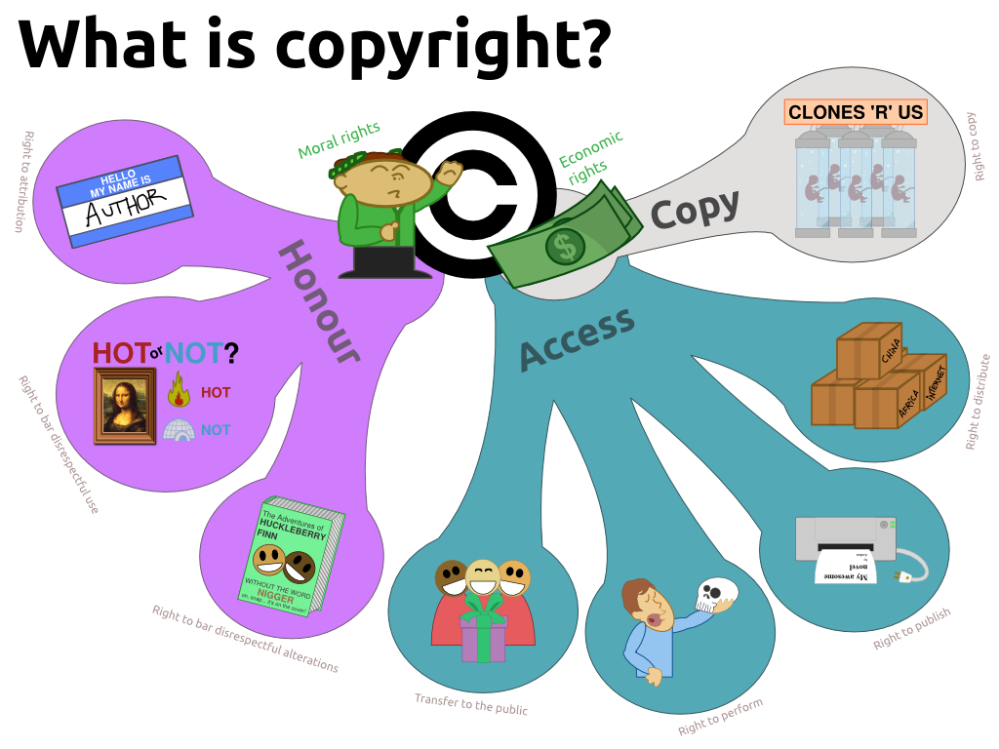
Source: https://mypad.northampton.ac.uk/09321145/2013/03/20/copyright-issues-and-internet-safety/
Contrary to popular belief, copyright in Poland allows the use of published works in a fairly wide range. This does not mean that we can do whatever we like - there are a few basic rules to keep in mind.
Figure 22. The basic principles of copyright

Source: own elaboration based on materials from Exacto Sp. z o.o.

Using works based on a CC license (Creative Commons)
There are works whose authors renounce property rights (in some countries where it is possible, authors may also waive personal rights). This means that their use is not subject to such restrictive rules - certain rules exist, depending on the license used (about their types below). A common feature of all CC licenses is the fact that you do not have to pay for the use of works.

Figure 23. Types of works based on a CC license
Source: own elaboration based on materials from Exacto Sp. z o.o.

Licenses can consist of several elements. For example, CC-BY-NC-ND allows only re-use (without editing) of the work for non-commercial purposes, while recognizing the authorship of the work.
Figure 24. Actions that violate copyright law
Source: own elaboration based on materials from Exacto Sp. z o.o.

Adherence to the guidelines presented in the above chapter will allow for the conscious and lawful use of materials available on the Internet.

Exercise
- Find a few texts about a topic you are interested in and improve them so that they become more attractive to the reader. Remote
- Find a few photoreports of events taking place related to a topic that interests you. Rate them in terms of their correctness. What is good about them and what needs improvement? Remote, Oral
- Try to find an infographic that outlines the topics your business focuses on. Is it presented in an interesting way? What catches your attention the most? Remote, Oral

- Tips for increasing the number of visits to the website
Each website - regardless of whether it is a company website, or maybe a blog or other online creation - needs traffic in order to exist. Why is traffic on a website so important? It is the source of readers, clients and potential customers, which is why it is worth taking care of acquiring constantly new, incoming traffic to our target site.
Figure 25. Tips for increasing the number of visits to the website

Figure 26. Tips for increasing the number of visits to the website, continued

Figure 27. Tips for increasing the number of visits to the website, continued

Source: https://www.whitepress.pl/baza-wiedzy/44/21-inspiracji-na-zwiekszenie-ruchu-na-stronie-internetowej

- Further information
- What is CMS and do I need it?
CMS stands for Content Management System. It is a website with an administration panel that allows you to change content independently and without programming knowledge. Adding, modifying and deleting texts, tables, graphics, photos, videos on the website, and even entire subpages and sections is done by clicking buttons. When writing text, you can use buttons to format text (such as bolding, inserting a reference), which are very similar to those in Word.
The most popular CMS systems have (usually free) add-ons, called plugins, which can be, for example, a photo gallery, a set of accessories to assist in positioning, a discussion forum, a hotel reservation system or even the Facebook "Like" button. Installing the plugin is usually limited to entering its name and clicking one button, if you use a sufficiently modern CMS system, such as WordPress. So plugins allow for free expansion of the functionality of a website without programming knowledge.
Another great advantage of CMS is the lack of fees for modifying websites that are equipped with such a system. You do not need to turn to an IT company, sign contracts, arrange details and wait for an order to be carried out, because everything can be done immediately.
Currently, there are practically no websites being set up that are not equipped with CMS.

Figure 28. What is a Content Management System (CMS)?
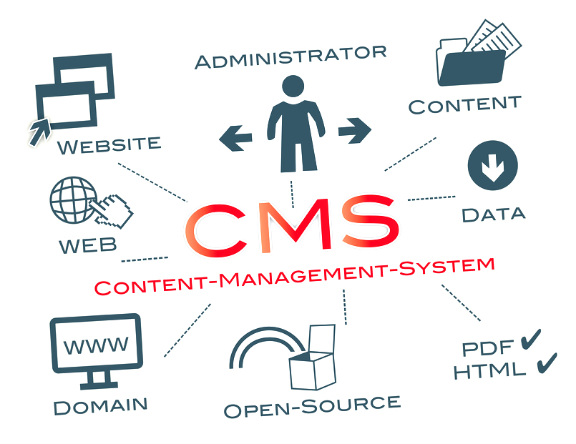
Source: http://www.motionborg.net/services/content-management-system-cms/

The construction of CMS (like any computer software) is very similar to the construction of a car - it looks simple from the outside, but has a complex structure on the inside, which in the case of CMS appears in the form of thousands of lines of programming code, called source.
Developers can reveal such code publicly (usually for free) or make it available only for customers to whom they have sold their software. Due to this "code openness", CMS systems fall into two categories, described below.

Figure 29. Types of CMS systems according to their source code

Source: https://sukcesstrony.pl/co-to-jest-cms
It should be remembered that the use of a free CMS does not mean that the site will be cheaper to set up, because in both cases you pay for its installation, configuration, customization or connection of the graphic design. So you can expect a similar price for the site, regardless of the openness of the code used to build it.
In Poland, reasonable prices for the creation of CMS-based websites start at PLN 3,000 and end at PLN 9,000, depending on the needs of the plugin configuration (additions extending the functionality of the application), the complexity of the graphic design and the quality of the site's set-up by the contractor.
The set-up time of a CMS-based site is usually (depending on the contractor) between two and three weeks.

Figure 30. The 10 most popular CMS content management systems

Source: https://mobiletry.com/blog/10-najpopularniejszych-systemow-do-zarzadzania-trescia-cms
- Website positioning - what is it and what does it depend on?
In articles about online marketing, the mysterious abbreviation SEO often appears. It stands for Search Engine Optimization, otherwise known as positioning, and thus it refers to the pursuit of obtaining a high position for a website in a search engine. This is a key issue for companies focused on gaining customers in the network. The best positioning effects can be obtained by employing an external SEO agency. However, this is a costly solution that not every company can afford, so a cheaper alternative is to independently master the rules of positioning, which can help you get satisfactory results.
Positioning for small businesses
The first step in the positioning of a small business website is to analyse the current market situation. You need to take into account other long-standing companies that are much larger and have won and still maintain a high position in Google. After entering general wording, such as "news", their websites appear in the first places, so it does not make sense to attempt to join the competition for such simple, popular phrases.
The solution for smaller companies can therefore be positioning under less popular wording. A city news portal should not try to get the phrase "news", which is occupied by nationwide portals. It is better to subordinate its positioning to wordings such as "black news" or "black information".
For online stores where location plays no role, it is a better solution to try positioning focused on specific products/services, especially those rarely found. For example, for a shop with folk handicraft, the design of one of the phrases may look like this: "brand name + store" or "name of the creation + online store". This is an approach in line with the idea of the so-called long tail, in which the point is that statistically more traffic is generated by low-popular phrases - that is, for example, 25 weak phrases will collect more hits than one strong one, most often typed in Google. So it is more profitable to position yourself in terms of many weaker, more complex phrases than to put time and money in the fight for super-popular and simple wording.
Positioning - site design and content
The success of positioning is determined not only by well-structured phrases, but also by the structure of the page and its content. First of all, remember the basic principles of web usability (ownership of products that determines their usable quality) and using your own solutions, not ready-made templates. The site must be convenient for all users, including mobile ones.
Taking into account the content, one should remember about the principles of content marketing, thus providing interesting and original information to Internet users. In a sense, it is enforced by Google itself, which introduced two complex algorithms (Panda and Penguin), whose task is to conquer the positioning of those websites that offer valuable content, and thus reduce the position of pages that derive from someone else's achievements.
One should also remember about proper optimization, and thus content saturation with key words, dividing well-chosen subheadings and bolding the most important phrases. The length of the article is also important, but within reason, so that an increase in the number of pages does not result in a deterioration of their quality.

Figure 31. The main goal of positioning on the Internet
Source: https://msstarkscience.weebly.com/blog/just-how-an-seo-consultant-could-expand-your-business

Positioning in social media
An important activity for every company/institution is running a fanpage on Facebook. To reach a wider range of users, you can also keep accounts on other social networks, such as: Google+, Twitter, Instagram or LinkedIn. However, it should be borne in mind that presence on these websites does not have much impact on positioning. The only dependency occurs when you have an account on Google+. On the other hand, activity on Facebook, and thus liking and sharing of our posts, does not improve the position in the search engine at all. So it is worth approaching social media from a different angle, in order to use them in such a way that they would help increase the number of visits to the website of our company/institution, which will increase its popularity.

Figure 32. Nine steps to a site that is friendly to positioning on Google

Source: https://poradnikprzedsiebiorcy.pl/-pozycjonowanie-czym-jest-i-na-czym-polega
Website positioning - link building
Even the best website design and optimization will not provide us with a high position in the Google search engine if we do not obtain external links to it, and so they should be placed on other websites and lead to our website.
Currently, quality of links counts more than their number, so before adding a link on a selected page, it is worth checking its indicators using tools such as Majestic, Ahrefs or Open Site Explorer.
Links should be obtained from various sources, because getting them, for example, only from online forums or only from page directories, will be a clear signal to Google that linking is being done in an unnatural way, which may result in the site falling in the search results.
In the case of a local company, it is worth adding your business card to Google Maps. This can help you get higher in the search results, and a business with a stationary headquarters can be easily found online.
Figure 33. Frequently encountered myths about SEO

Source: https://www.whitepress.pl/baza-wiedzy/36/na-czym-polega-pozycjonowanie-stron-internetowych

Where to look for help in positioning websites
Positioning work can be outsourced to specialists or you can try to do it yourself. Both solutions have their pluses and minuses, but for self-directed activities to bring more benefits, it is worth looking for help on the following pages:
- Groups in social networks, bringing together people involved in positioning:
- https://www.facebook.com/groups/496083163758299/ – SEO/SEM Polska group on Facebook
- https://plus.google.com/u/0/communities/111407465367186518896 – SEO Poland group on Google+
- Google Forum for Webmasters – https://productforums.google.com/forum/?hl=pl#!categories/webmaster-pl/
- The biggest Polish SEO forum – http://www.forum.optymalizacja.com/
- New SEO Concept Group

Exercise
- Check which websites are displayed in Google search by entering topics of interest to you. Remote
- Identify your biggest competitors. Remote

- Tips for creating content on the Internet
This chapter contains advice on how to properly create materials for publication on the Internet.
  - Creating press releases
The press release is one of the basic tools for communication with journalists. It is a message addressed to individual media in order to publish information about a given institution. The better the material is edited, the greater the chance of its publication.
First of all, the message must be concise and meaningful. The beginning of the information must be interesting, because this determines whether the journalist will become acquainted with the whole text. It is also worth checking whether the message answers basic questions such as: who?, what?, where?, when?, why? and how? However, the correctness of the press release does not guarantee that it will be used by journalists. Other activities are necessary to increase media interest. The text must of course be checked and must not contain any errors. It is also necessary to supplement the material with photos, graphics, information about the company/institution, or - if possible - charts.
The first step, before creating content, is to prepare an appropriately profiled database of journalists. The message must get to a journalist who might be interested in the topic. This is a tedious task, often requiring repeated direct contact with editors. In addition, this type of contact database must be regularly updated.
Calling journalists after sending a press release is an activity that can increase the number of publications. Some media representatives do not like direct contact because they do not have time, and a conversation by itself will not make them interested in a topic. On the other hand, it can contribute to a deepening of the relationship and will make sure that the information has reached the recipient.
Figure 34. Errors to avoid when creating press releases
Source: own elaboration based on materials from Exacto Sp. z o.o.
  - Reporting from events
The reporting of events, like other press forms, consists of a title, leader and essential content. It is a faithful and accurate description of the course of an event. In the report it is necessary to include answers to basic questions, such as: What happened? Where and when did this happen? Who is the hero? What was the event related to?
The basic features of the report are objectivity, transmission of events in chronological order and providing accurate, checked and truthful information.
Figure 35. Basic principles for creating reports
Source: own elaboration based on materials from Exacto Sp. z o.o.

  - Rules for the publication of photos from online databases
There are a few rules to keep in mind when posting photos from the Internet:
- There are photos from paid and free websites. In paid services for a certain amount it is possible to download photos for multiple use and modification, without the need to have their use signed off.
- The second option is to use free photo databases. In this case, you should pay attention to the license on the basis of which the photo is offered and comply with it. In most cases, photos from free sites are made available under a Creative Commons license, which allows sharing of content under certain conditions. Some of the sites offering free photos, e.g. Pixabay.com, require attribution of the source from which the image is taken.
- Also in the case of placing photographs, the name and surname of the author or institution lending the photo to the article or page should be given each time. The use of a photo without the consent and knowledge of the author may be associated with financial and legal consequences.
  - Creating photoreports
Creating successful photojournalism is based on a few basic principles related to proper preparation, observing the rules of correct shooting, as well as skilful graphic processing and composition of the finished material.
A properly prepared photoreport enables us to present the photographed event in a way that will allow people who were present to remember it, and those who were not to become familiarized with it. The basis for a successful photoreport is the appropriate selection of photos, during which photos will be rejected that are repeated, out of focus, incorrectly cropped or raise objections in the context of image rights.
Figure 36. The basic rules for creating photoreports
Source: own elaboration based on materials from Exacto Sp. z o.o.

  - Creating infographics for publication on a portal
A very good way to increase the attractiveness of information and create an in-depth explanation of a topic is to prepare special infographics, which are then published with text materials. This is an eye-catching form of presentation of, often complex, content which at the same time allows the reader to quickly and easily understand the problem. This is particularly important due to the fact that not every user has the desire and time to get to know the content thoroughly. In the case of publishing an infographic, the person's eyesight is automatically directed toward it, because it draws attention with its attractiveness. An additional advantage of infographics is the fact that they often have a "viral" potential, but in a positive sense, i.e. they can be shared and passed further by Internet users and thus can widely increase the range of recipients. In connection with the above-mentioned facts, it is recommended in the case of complicated issues to prepare specially designed infographics for them.
Figure 37. The basic principles for creating infographics
Source: own elaboration based on materials from Exacto Sp. z o.o.

- Bibliography
Scientific literature
- UMW Report, May 2016
- UMW Report, June 2016,
- UMW Report, August 2016
- UMW report, September 2016,
- UMW Report, November 2016
- UMW Report, January 2017
- UMW report, March 2017,
- UMW Report, April 2017
- UMW report, June 2017
- UMW report, August 2017,
- UMW Report, September 2017,
- UMW report, December 2017.

Electronic publications
- http://amarketingexpert.com/wp-content/uploads/2014/09/Newsletter-Publishing-Best-Practices.png, za dzień 19.12.2018,
- http://echopr.pl/blog.php?id=26, za dzień 17.12.2018,
- http://emarketingblog.nl/2014/11/best-tips-for-email-marketing/, za dzień 19.12.2018,
- http://motionborg.net/services/content-management-system-cms/, za dzień 19.12.2018,
- https://iqinfotech.co.in/blog/benefits-of-email-marketing/, za dzień 19.12.2018 ,
- https://jakzalozycstrone.info/8-artykuly/21-serwer-i-hosting.html, za dzień 19.12.2018,
- https://jakzalozycstrone.info/wybor-serwera-i-domeny.html, za dzień 14.12.2018,
- https://marketingibiznes.pl/e-mail-marketing/abc-e-mail-marketingu-czyli-wysylac-mailingi-glowa/, za dzień 14.12.2018,
- https://mobiletry.com/blog/10-najpopularniejszych-systemow-do-zarzadzania-trescia-cms, za dzień 19.12.2018,
- https://msstarkscience.weebly.com/blog/just-how-an-seo-consultant-could-expand-your-business, za dzień 19.12.2018,
- https://mypad.northampton.ac.uk/09321145/2013/03/20/copyright-issues-and-internet-safety/, za dzień 19.12.2018,
- https://poradnikprzedsiebiorcy.pl/-pozycjonowanie-czym-jest-i-na-czym-polega, za dzień 14.12.2018,
- https://sukcesstrony.pl/co-to-jest-cms, za dzień 14.12.2018,
- https://websitesetup.org/what-is-web-hosting/, za dzień 19.12.2018,
- https://websitespot.com/blog/what-is-domain-name-infographic/, za dzień 19.12.2018,
- https://whitepress.pl/baza-wiedzy/36/na-czym-polega-pozycjonowanie-stron-internetowych, za dzień 14.12.2018,
- https://whitepress.pl/baza-wiedzy/44/21-inspiracji-na-zwiekszenie-ruchu-na-stronie-internetowej, za dzień 14.12.2018.

https://jakzalozycstrone.info/wybor-serwera-i-domeny.html, on 14.12.2018
https://www.websitespot.com/blog/what-is-domain-name-infographic/, on 19.12.2018
https://websitesetup.org/what-is-web-hosting/, on 19.12.2018
https://jakzalozycstrone.info/8-artykuly/21-serwer-i-hosting.html, on 19.12.2018
https://marketingibiznes.pl/e-mail-marketing/abc-e-mail-marketingu-czyli-wysylac-mailingi-glowa/, on 14.12.2018
https://www.iqinfotech.co.in/blog/benefits-of-email-marketing/, on 19.12.2018
http://emarketingblog.nl/2014/11/best-tips-for-email-marketing/, on 19.12.2018
http://www.echopr.pl/blog.php?id=26, on 17.12.2018
http://www.amarketingexpert.com/wp-content/uploads/2014/09/Newsletter-Publishing-Best-Practices.png, on 19.12.2018
UMW_0817
UMW_0117
UMW_0616
UMW_1217
UMW_0417
UMW_1116
UMW_0917
https://mypad.northampton.ac.uk/09321145/2013/03/20/copyright-issues-and-internet-safety/, on 19.12.2018
https://www.whitepress.pl/baza-wiedzy/44/21-inspiracji-na-zwiekszenie-ruchu-na-stronie-internetowej, on 14.12.2018)
https://sukcesstrony.pl/co-to-jest-cms, on 14.12.2018
http://www.motionborg.net/services/content-management-system-cms/, on 19.12.2018
https://mobiletry.com/blog/10-najpopularniejszych-systemow-do-zarzadzania-trescia-cms, on 19.12.2018
https://poradnikprzedsiebiorcy.pl/-pozycjonowanie-czym-jest-i-na-czym-polega, on 14.12.2018
https://msstarkscience.weebly.com/blog/just-how-an-seo-consultant-could-expand-your-business, on 19.12.2018
https://www.whitepress.pl/baza-wiedzy/36/na-czym-polega-pozycjonowanie-stron-internetowych, on 14.12.2018
UMW_0816
UMW_0916
UMW_0516
UMW_0617
UMW_0317

